Links dos autores


https://displate.com/wsbcreativeart

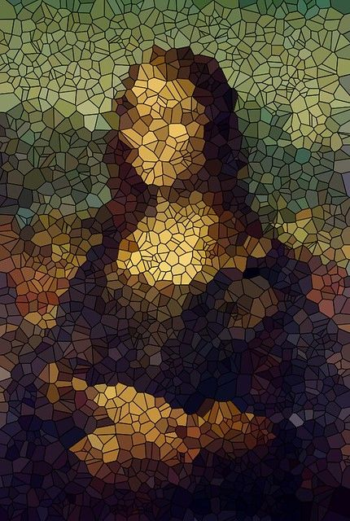

https://www.flickr.com/photos/vormplus/5986548393/

